Project Proposal

### **1. Executive Summary**

This project aims to develop a standardized AI-powered application for Broadaxis to streamline and automate a wide range of business development and operations tasks. These include responding to RFPs, RFIs, and RFQs; handling DIR requirements; managing candidate submissions through vendor portals; replying to client emails; and formatting documents such as resumes and proposals.

The platform will enhance speed, consistency, and accuracy in executing these workflows. By leveraging existing data, AI summarization, and workflow automation, the tool will drastically reduce manual effort, improve turnaround times, and increase organizational efficiency.

### **2. Problem Statement / Opportunity**

Reviewing and responding to RFPs, RFIs, and RFQs at Broadaxis involves a multi-step manual workflow—evaluating the opportunity, making a go/no-go decision, dividing tasks among team members, drafting content, formatting documents, and conducting final reviews. This process is often labor-intensive and can take weeks to months depending on the proposal size and complexity.

There's a significant opportunity to leverage AI to categorize opportunities, suggest relevant historical responses, track deadlines, and assist in document formatting. This will reduce the manpower and time required while ensuring consistency and speed in responses.

### **3. Proposed Solution**

We propose building a web-based application that standardizes and automates multiple business development tasks, including:

* Responding to RFPs, RFIs, RFQs
* Handling DIR requirements (State of Texas, Georgia)
* Submitting candidate profiles in vendor portals
* Responding to email-based requests
* Formatting resumes and documents based on specifications

The tool will leverage AI and historical data to summarize requirements, recommend actions, fill in data, and assist with submission workflows. While the long-term goal is to build a centralized system covering all the above, the first few Phases **will focus solely on RFP/RFI/RFQ automation** to validate the core functionality.

Key features will include:

* Retrieving RFPs/RFIs/RFQs from emails or portals (via API)
* AI (Claude + RAG architecture) summarizing requirements and providing go/no-go decisions
* Auto- generate response forms/documents using internal database content
* Human review for final edits before submission

Future phases will expand to include formatting engines, auto-submission capabilities, and support for DIR, vendor portals, and email workflows.

**Phase 1** will focus on the database, proposal request summarization, and auto-fill responses. **Phase 2** will include integration with RFP portal (tool) and formatting tools. **Phase 3** will enable submissions via portal integration.

### **4. Workflow Overview**

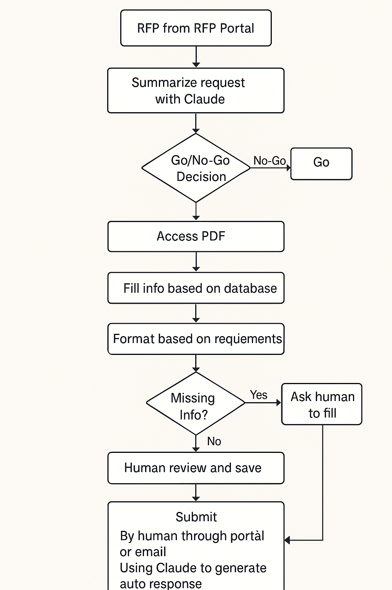

1. **RFP Retrieval**
   1. RFP, RFI, or RFQ is downloaded from a portal and saved on the desktop in a designated folder.
2. **AI Summarization**
   1. Claude is used to summarize the document, extracting key requirements including formatting instructions.
3. **Go/No-Go Decision**
   1. AI compares the RFP requirements with internal Broadaxis data using a RAG model.
   2. Decision is made based on historical performance and predefined criteria.
4. **Document Parsing and Auto-fill**
   1. PDF or DOC files are accessed one by one.
   2. Claude auto-fills fields using the internal database (company and past submission data).
5. **Formatting**
   1. Formatting is applied based on requirements captured in the AI summary.
6. **Human Review**
   1. Final documents are reviewed by a team member.
   2. Missing information is flagged and requested from the reviewer.
7. **Save and Submit**
   1. Final version is saved to the desktop folder.
   2. Submission is either manual (through portal or email) or auto-generated by Claude based on response templates.

### **5. Scope of Work**

**In Scope (Phase 1):**

* Internal database setup (company info, previous submissions, profiles)
* Claude integration for AI summarization and go/no-go logic
* Document parsing and auto-fill based on AI summary

### **6. Timeline and Milestones**

|  |  |  |  |
| --- | --- | --- | --- |
| **Phase** | **Duration** | **Focus Areas** | **Milestone** |
| Phase 1 | July 1–July 31 | Database setup, RFPAI summarization, auto-generate response | MVP |
| Phase 2 | Aug 1–Aug 31 | Formatting tool, RFP portal API integration | Format-ready automation, API integration |
| Phase 3 | Sept 1–Sept 30 | Email tool, auto-submission logic | Portal-enabled auto-response |

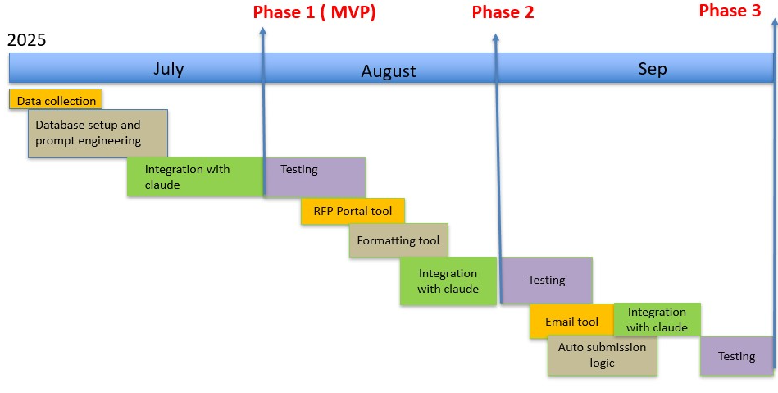

### **7. Budget and Resources**

|  |  |
| --- | --- |
| **Category** | **Cost Estimate** |
| Claude Access | $16.67/month |
| Render (Servers & Testing) | $85/month |
| Azure (Deployment & Security) | $0.60/month |
| Database (PostgreSQL + RAG) | Free |
| **Total** | **~$103+ Monthly Ops** |

### **8. Risk Management**

|  |  |  |
| --- | --- | --- |
| **Risk** | **Likelihood** | **Mitigation Strategy** |
| AI inaccuracy | Medium | Human review step before submission |
| Hallucinations/irrelevant answers | High | Guardrails and prompt engineering |
| API integration delay | High | Focus on file-based ingestion in Phase 1 |
| Scope creep | Medium | Phased delivery with strict scope control |

### **9. Stakeholders**

* Divya – Project Manager
* Rohith – Developer, Architect, QA
* Sakshi – Developer, QA
* Masood, Pravartika - Client
* Taimur, Abeer, Uzi – Data collection

### **10. Technical Requirements**

* **Backend:** Python (Django)
* **Frontend:** React
* **AI Integration:** Claude, RAG
* **Cloud:** Azure
* **Database:** PostgreSQL
* **Integrations:** RFPportals (via API)
* **Backlog:** JIRA

### **11. Success Metrics**

* **Time to Market:** Deliver MVP (Phase 1) within 30 days
* **Value (Quantifiable Impact):** 60–80% reduction in manual effort; faster RFP turnaround
* **Least Effort, Maximum Result:** Achieve high efficiency and automation with minimal input—95% output from 5% manual intervention
* **Scalability:** Modular design enables easy expansion to DIR, vendor portals, and other domains
* **Sustainability:** Operable by a small team with low ongoing costs and manageable resources
* **Dependency :** Reduced reliance on individual contributors by embedding knowledge and decision logic in AI workflows

### **12. Future Enhancements**

* Add tools to handle DIR requirements, vendor portals, and email workflows
* Develop and refine formatting engine for resumes and proposals
* Design intuitive and responsive UI
* Implement MFA and enhanced access control
* Integrate reasoning-based LLMs for improved decision-making
* Extend platform to other domains beyond business development